DocSpot Booking– Seamless Appointment Booking for Health.

Team Members:
Jagadish M
Bheemesh A
Hanshith E
Karthik M
Pathan Asif
Team Id: LTVIP2025TMID53627
Course Name: Full Stack Developer (MERN STACK)

Abstract

In today’s fast-paced world, traditional methods of booking doctor appointments often lead to inefficiencies, long wait times, and poor coordination between patients and healthcare providers. DocSpot Booking aims to address these challenges by providing a seamless, user-friendly, and real-time web-based appointment booking system.
This full-stack application enables patients to browse a curated list of doctors, filter them by specialization or availability, and book appointments at their convenience. Doctors can manage their schedules, approve or reject appointments, and track their consultations. An admin panel governs the platform by verifying doctor applications and ensuring policy compliance.
The project is developed using the MERN stack — MongoDB, Express.js, React.js, and Node.js — ensuring efficient data handling, real-time responsiveness, and scalable architecture. Features like role-based access, JWT-based authentication, and MongoDB integration enhance the security and performance of the application.
DocSpot Booking not only simplifies the healthcare appointment process but also offers a digital solution that can be expanded to support telemedicine, digital prescriptions, and patient record management in the future.

Contents
- INTRODUCTION
  - Project Overview
  - Purpose
- IDEATION PHASE
  - Problem Statement
  - Empathy Map Canvas
  - Brainstorming
- REQUIREMENT ANALYSIS
  - Customer Journey map
  - Solution Requirement
  - Data Flow Diagram
  - Technology Stack
- PROJECT DESIGN
  - Problem Solution Fit
  - Proposed Solution
  - Solution Architecture
- PROJECT PLANNING & SCHEDULING
  - Project Planning
- FUNCTIONAL AND PERFORMANCE TESTING
  - Performance Testing
- RESULTS
  - Output Screenshots
- ADVANTAGES & DISADVANTAGES
- CONCLUSION
- FUTURE SCOPE
- APPENDIX
Source Code(if any)
Dataset Link
GitHub & Project Demo Link

1. INTRODUCTION
1.1 Project Overview
DocSpot Booking is a full-stack web application designed to modernize and streamline the process of booking medical appointments. In an age where digital convenience is transforming industries, healthcare continues to face challenges such as long waiting periods, inefficient scheduling, and manual booking processes. DocSpot Booking addresses these challenges by providing a centralized, digital platform where patients, doctors, and administrators interact seamlessly.
The application is developed using the MERN stack — MongoDB, Express.js, React.js, and Node.js — offering a responsive user interface, robust server-side logic, and scalable database management. Users can register and search for doctors based on specialization, availability, and location. Doctors can register themselves through a detailed form, which goes through an approval process by the admin to ensure legitimacy and professional quality.
Once approved, doctors can view and manage their schedule, confirm or reject appointments, and update their availability. Admins oversee the platform’s operations by validating doctor applications, resolving conflicts, and ensuring smooth user interaction.
The system supports role-based dashboards — ensuring that each user type (patient, doctor, and admin) has access to relevant features only. This not only maintains the integrity and security of the application but also enhances user experience by presenting them with intuitive interfaces tailored to their roles.
In addition to appointment booking, the platform also allows patients to upload supporting medical documents (e.g., test reports or prescriptions) during the booking process, helping doctors prepare ahead of time for more effective consultations.
The platform’s real-time features, combined with its responsive design and structured user management, make DocSpot Booking a practical solution for digitizing healthcare services in clinics, hospitals, and telemedicine environments.
1.2 Project Purpose
The primary purpose of the DocSpot Booking application is to bridge the gap between patients and doctors by eliminating the inefficiencies of manual appointment systems and replacing them with an intuitive, online platform. Key motivations behind this project include:
- Enhancing Patient Convenience:
Allow users to book medical appointments from anywhere, at any time, without the hassle of phone calls or in-person visits.
- Improving Doctor Workload Management:
Provide doctors with a centralized dashboard to manage their appointments, check availability, and handle patient interactions efficiently.
- Ensuring Platform Trust and Professionalism:
Introduce an admin-controlled approval system to validate doctors, ensuring that only verified professionals appear on the platform.
- Encouraging Digitization in Healthcare:
Support digital uploads of documents, real-time updates, and transparent scheduling, laying the groundwork for future integrations such as electronic medical records (EMR), e-prescriptions, and teleconsultations.
- Scalability and Adaptability:
Build a modular and scalable platform that can be deployed in clinics, hospitals, or even converted into a full-featured telemedicine solution in the future.
By fulfilling these objectives, DocSpot Booking not only simplifies the appointment process for individual users but also contributes to a more organized and tech-enabled healthcare ecosystem.

2. IDEATION PHASE

2.1 Problem Statement
In today’s fast-paced and digitally connected world, patients often experience frustration and delays when trying to book doctor appointments. They are frequently required to:
- Wait on lengthy phone calls or visit clinics in person just to schedule an appointment.
- Deal with uncertainty regarding doctor availability.
- Repeat the same process every time they need care, wasting time and effort.
- Lack visibility into appointment confirmation, cancellation, or status updates.
- Share medical documents manually, sometimes repeatedly.
These challenges create an inconvenient and inefficient experience for patients who are already stressed due to their health concerns. On the other hand, doctors and clinic staff often struggle to manage appointments manually, which results in miscommunication, overbookings, or missed opportunities.
Importance
Patients want a simple, trustworthy, and time-saving way to connect with healthcare providers. They seek a platform where they can:
- Quickly find available and verified doctors
- Easily book appointments based on their schedule
- Receive instant confirmation and updates
- Upload relevant documents in advance for better consultations
Doctors, too, need a streamlined system that allows them to manage schedules efficiently and focus more on patient care rather than administrative tasks.
2.2 Empathy Map Canvas
Understanding the patient's experience in booking medical appointments
USER
A digitally aware patient who wants to book an appointment with a doctor online, without having to visit a hospital or call a receptionist.
SAYS
- “I don’t want to waste time calling the clinic.”
- “I wish I could see when the doctor is available.”
- “I want to upload my medical files easily.”
- “Why is booking so complicated these days?”

THINKS
- “Will the doctor see me on time?”
- “What if I need to reschedule at the last minute?”
- “Is my personal information safe here?”
- “I hope this doctor is genuine and approved.”
SEES
- Long queues and overbooked hospitals
- Unclear or unavailable appointment slots
- Other healthcare apps that are either outdated or lack necessary features
- Multiple apps for different doctors or hospitals
HEARS
- “The clinic won’t pick up the phone!”
- “This doctor is always booked.”
- “Try booking online — it might be easier.”
- “Make sure the doctor is actually registered.”
DOES
- Browses different platforms to find doctor availability
- Calls clinics/hospitals repeatedly for information
- Searches online reviews to verify doctor credibility
- Takes photos or scans documents for appointments
PAINS
- Difficulty in finding reliable and timely appointments
- No confirmation or real-time feedback after booking
- Frustration with apps that are hard to use or outdated
- Worry about data privacy and professional legitimacy
GAINS
- Confidence in booking with verified doctors
- Real-time updates and reminders
- Easy upload of medical documents
- The ability to reschedule or cancel with just a click
- Time saved — no calls, no waiting

2.3 Brainstorming
Step-1: Team Gathering, Collaboration and Select the Problem Statement
Problem Statement Chosen:
"Users find it time-consuming and unreliable to book doctor appointments through existing systems, often lacking visibility on doctor availability, booking confirmation, and proper communication."
- Team members gathered: Frontend devs, Backend devs, and UI/UX
- Shared user pain points, feature ideas, and competitor research
- Identified key challenge: Booking experience & real-time status clarity
Step-2: Brainstorm, Idea Listing and Grouping
Grouped Brainstormed Ideas:
User Experience (UX/UI)
- One-click appointment booking
- Real-time calendar with slot visibility
- Responsive mobile-friendly design
- Live chat with clinic admin
- Dark mode for low-light users
Core Features
- Doctor profile with ratings/reviews
- Search doctors by specialty/location
- Instant appointment status updates
- OTP-based patient verification
- Auto-email reminders for appointments
Notifications & Reminders
- SMS/email reminders for appointments
- Notification if a doctor cancels/reschedules
- Feedback form after appointment
Security & Data
- Encrypted patient-doctor chat
- JWT-based authentication
- Role-based access control (Admin, User, Doctor)
Doctor & Admin Tools
- Admin can approve/reject doctor applications
- Doctor can set availability slots
- Dashboard showing upcoming appointments
- Analytics on daily/monthly bookings

Innovative Add-ons
- AI chatbot for common queries
- Emergency appointment request option
- Voice-enabled booking assistant
- Integration with Google Calendar
- QR Code check-in system at the clinic
Step-3: Idea Prioritization
Effort vs. Impact Prioritization Table
Idea | Effort | Impact | Priority
Real-time slot booking calendar | High | Very High | Must Have
Doctor profile with specialization & ratings | Medium | High | Must Have
Admin dashboard for appointment control | Medium | High | Must Have
Email/SMS notification system | Medium | High | Implement Soon
Live chat with doctor/admin | High | Medium | Future Consideration
Dark mode support | Low | Medium | Quick Add-on
OTP-based patient verification | Medium | High | Implement Soon
Google Calendar sync | High | Medium | Later Phase
AI chatbot integration | Very High | High | Optional
Feedback system after appointment | Low | Medium | Easy & Valuable

3. REQUIREMENT ANALYSIS
3.1 Customer Journey Map
This customer journey map illustrates the experience of a typical user (patient) interacting with the DocSpot Booking– Seamless Appointment Booking System, from the initial awareness of needing medical care to the follow-up after the consultation. It highlights key actions, goals, thoughts, challenges, and opportunities for improving the user's journey.
Stage | User Actions | User Goals | User Thoughts & Feelings | Pain Points | Opportunities
1. Awareness | • User feels unwell and realizes they need a doctor  • Searches online | • Find a doctor quickly and easily | “I need a doctor, but I don’t want to wait in line or call clinics.” | • No info on doctor availability  • Difficulty reaching clinics | • Targeted ads or SEO for DocSpot  • Word-of-mouth promotion
2. Consideration | • Visits DocSpot  Booking  • Browses doctor profiles  • Reads reviews, checks timings | • Choose a reliable, nearby doctor  • Check ratings | “This doctor looks good, but are they available tomorrow?” | • Unclear or outdated doctor info on other platforms | • Real-time doctor availability  • Verified doctor profiles
3. Booking | • Logs in / registers  • Fills appointment form  • Uploads documents | • Secure a confirmed appointment at a suitable time | “This was easier than calling. I hope it gets approved quickly.” | • Delayed confirmation  • No visibility on status | • Instant confirmation or real-time status updates
4. Confirmation | • Receives booking status  • Gets email/SMS alert with appointment details | • Know exact time, location, and what to bring | “Great, my appointment is booked!” | • Confusion if doctor reschedules/cancels | • Notifications for every update  • Easy reschedule options
5. Consultation | • Visits doctor  • Receives medical care  • Doctor updates records | • Get proper treatment and next steps | “The doctor was prepared because they saw my uploaded files.” | • Forgetting documents  • Rushed appointments | • Allow uploading documents in advance  • Visit summary notes
6. Follow-up | • Receives visit summary  • May need to book a follow-up  • Leaves feedback | • Complete treatment cycle  • Help others with reviews | “I’ll rate this doctor. Everything went smoothly.” | • Forgetting follow-up dates  • Lack of closure | • Feedback prompts  • Auto-suggest follow-up bookings

3.2 Solution Requirements (Functional & Non-functional)
Functional Requirements:
Following are the functional requirements of the proposed solution.
FR No. | Functional Requirement (Epic) | Sub Requirement (Story / Sub-Task)
FR-1 | User Registration | • Registration through Form• Email & Password authentication
FR-2 | User Login | • Login with Email & Password• Role-based login (User/Doctor/Admin)
FR-3 | Doctor Application | • Apply as Doctor• Admin approval of Doctor application
FR-4 | Appointment Booking | • Browse doctors by filters• Book appointments with preferred date & time
FR-5 | Appointment Management | • View booking history• Cancel or reschedule appointments
FR-6 | Notification System | • Email notification on booking, cancellation, confirmation
FR-7 | Admin Panel | • Approve/reject doctor registrations• Manage users & doctors
FR-8 | Doctor Dashboard | • Set availability• Manage and update appointment statuses
FR-9 | Upload & View Documents | • Patients can upload reports• Doctors can view patient records
FR-10 | Feedback & Summary | • Send consultation summary• Capture user feedback
Non-functional Requirements:
Following are the non-functional requirements of the proposed solution.
NFR No. | Non-Functional Requirement | Description
NFR-1 | Usability | Easy-to-use and intuitive UI for patients, doctors, and admins
NFR-2 | Security | Secure login, data protection using encryption and role-based access control
NFR-3 | Reliability | High reliability with real-time updates and error handling
NFR-4 | Performance | Fast load times, efficient data fetching using REST APIs and optimized database
NFR-5 | Availability | 24/7 accessible platform with minimal downtime
NFR-6 | Scalability | Scalable backend to handle growing number of users, appointments, and doctors
3.3 Data Flow Diagram
The Data Flow Diagram (DFD) represents how data flows through the DocSpot Booking system, highlighting the interaction between users (patients, doctors, admin), external systems, and the internal modules responsible for registration, appointment management, and communication.
DFD Level 0 – Context Level
At Level 0, the system is treated as a single process with external entities interacting through defined interfaces. It includes the following data flows:
- Patients register/login and book appointments
- Doctors manage their availability and appointments
- Admin verifies doctors and oversees platform activities
- The system stores and retrieves data from the database
Admin
Patient
Doctor
Database

DocSpot Booking System

3.4 Technology Stack
The project utilizes a MERN (MongoDB, Express.js, React.js, Node.js) stack to build a full-stack web application for doctor appointment booking.
Frontend (Client-side)
Technology | Purpose
React.js | Core library for building the interactive user interface
JavaScript (ES6) | Logic handling and asynchronous calls
HTML5 | Markup language to structure web pages
CSS3 | Styling and layout
Bootstrap | Responsive design and pre-styled components
Material UI (MUI) | UI component library for modern design
Axios | For making HTTP requests from React to the backend
React Router | Navigation and route handling in single-page application
Backend (Server-side)
Technology | Purpose
Node.js | Runtime environment for executing JavaScript on the server
Express.js | Web framework for Node.js to build RESTful APIs
Multer | Middleware for handling file uploads (e.g., documents)
Nodemon | Tool for automatically restarting the server on file changes
Database
Technology | Purpose
MongoDB | NoSQL database for storing documents related to users, doctors, appointments
Mongoose | ODM (Object Data Modeling) library to interact with MongoDB from Node.js
Authentication & Security
Technology | Purpose
JWT (JSON Web Tokens) | Secure token-based user authentication
bcrypt.js | For hashing passwords before storing them in the database
Other Tools & Libraries
Tool/Library | Purpose
Moment.js | Date and time formatting
dotenv | Load environment variables from .env file
VS Code | Code editor used for development
Postman | API testing and debugging tool
MongoDB Compass | GUI for managing and viewing data in MongoDB

4. PROJECT DESIGN

4.1 Problem Solution Fit
Problem
Patients often face difficulties while booking doctor appointments through traditional means. These include:
- Long hold times on calls or unavailability of receptionists.
- No real-time information about doctor availability.
- No centralized platform for comparing and booking doctors based on specialization, location, or ratings.
- Manual appointment management, causing missed follow-ups or reschedules.
- Lack of clear communication or digital consultation history.
Healthcare professionals also face issues like:
- Inefficient appointment scheduling.
- No platform to manage patient flow or availability.
- Delayed or manual interaction with patients about updates or records.
Solution
DocSpot Booking is an online appointment booking system designed to bridge the gap between patients and healthcare providers with an intuitive, fast, and user-friendly platform.
Key Solution Features:
- Real-time availability of doctors with profile browsing.
- Role-based login for patients, doctors, and admin for streamlined access.
- Appointment booking, cancellation, and rescheduling with status tracking.
- Digital document upload (e.g., previous reports).
- Admin approval process to ensure only verified doctors join.
- Notifications for appointment confirmations and changes.
- Post-appointment summaries and medical follow-ups.
- Centralized dashboard for all users.
Purpose
- Solve complex scheduling and healthcare access problems using technology.
- Increase adoption by aligning with digital-first behavior of users (especially post-pandemic).
- Enable trust-building through verified doctor listings and communication transparency.
- Improve healthcare service delivery and planning with structured appointment systems.
- Offer convenience and reduce overhead for both patients and healthcare providers.

4.2 Proposed Solution
S. No. | Parameter | Description
1 | Problem Statement (Problem to be solved) | Traditional doctor appointment booking processes are inefficient, involving manual calls, delayed responses, and lack of transparency in doctor availability. This leads to inconvenience for patients and unstructured scheduling for doctors.
2 | Idea / Solution description | DocSpot Booking is a web-based appointment booking platform that allows patients to register, browse verified doctors, and schedule appointments based on real-time availability. Doctors can manage their schedules, and the admin oversees platform governance. The solution includes role-based access, notifications, document uploads, and a digital dashboard.
3 | Novelty / Uniqueness | Unlike generic booking systems, DocSpot Booking is tailored specifically for healthcare. It provides role-specific features for patients, doctors, and administrators. Real-time slot availability, profile verification, and post-consultation summaries enhance reliability and trust.
4 | Social Impact / Customer Satisfaction | DocSpot Booking simplifies access to healthcare, reducing waiting times and ensuring patients find the right doctor easily. It promotes better health outcomes through timely care and empowers users with control over their medical interactions.
5 | Business Model (Revenue Model) | Potential monetization strategies include subscription plans for doctors, featured listings for clinics, advertisement placements, and service fees on each confirmed appointment. A freemium model can attract initial users.
6 | Scalability of the Solution | The system is built on a scalable MERN stack architecture. It can be expanded to include additional features like teleconsultation, e-prescriptions, multilingual support, mobile apps, and integration with hospitals or labs across regions.

4.3 Solution Architecture
Solution architecture is a complex process – with many sub-processes – that bridges the gap between business problems and technology solutions. Its goals are to:
• Find the best tech solution to solve existing business problems.
• Describe the structure, characteristics, behavior, and other aspects of the software to project stakeholders.
• Define features, development phases, and solution requirements.
• Provide specifications according to which the solution is defined, managed, and delivered.

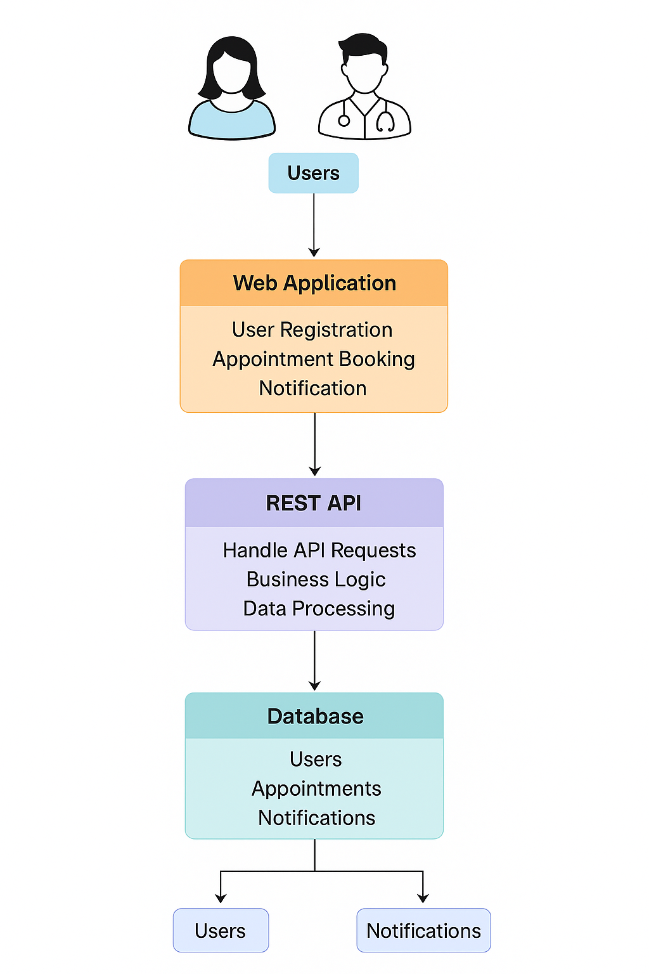

5. PROJECT PLANNING & SCHEDULING
5.1 Project Planning Document
Date: 21 June 2025
Project Name: DocSpot Booking - Seamless Appointment Booking for Health.

Product Backlog, Sprint Schedule, and Estimation
Sprint | Functional Requirement (Epic) | User Story Number | User Story / Task | Story Points | Priority | Team Members
Sprint-1 | Registration | USN-1 | As a user, I can register by entering email, password, and confirming password. | 2 | High
Sprint-1 |  | USN-2 | As a user, I will receive a confirmation email after registering. | 1 | High
Sprint-1 |  | USN-3 | As a user, I can register using Gmail. | 2 | Medium
Sprint-1 | Login | USN-4 | As a user, I can log in using email and password. | 1 | High
Sprint-1 | Data Collection | USN-5 | Collect user and doctor data from forms. | 2 | High
Sprint-1 | Data Preprocessing | USN-6 | Handle missing values in user inputs. | 3 | Medium
Sprint-1 |  | USN-7 | Handle categorical values for user roles. | 2 | Medium
Sprint-2 | Model Building | USN-8 | Build doctor recommendation model based on specialization and availability. | 5 | High
Sprint-2 |  | USN-9 | Test and validate model accuracy. | 3 | Medium
Sprint-2 | Deployment | USN-10 | Create working HTML pages for booking and profile features. | 3 | High
Sprint-2 |  | USN-11 | Deploy app using Node.js/Express & MongoDB. | 5 | High
Total Story Points:
Sprint 1 = 13
Sprint 2 = 16
Total = 29
Project Tracker, Velocity & Burndown Chart
Sprint | Total Story Points | Duration | Sprint Start Date | Sprint End Date (Planned) | Story Points Completed | Sprint Release Date
Sprint-1 | 13 | 3 Days | 21 Feb 2025 | 23 Feb 2025 | 13 | 23 Feb 2025
Sprint-2 | 16 | 3 Days | 24 Feb 2025 | 26 Feb 2025 | 16 | 26 Feb 2025
Velocity Calculation:
Total Story Points = 29
Number of Sprints = 2
Velocity = 29 / 2 = 14.5 story points per sprint

6. FUNCTIONAL AND PERFORMANCE TESTING
6.1 Performance Testing
Test Scenarios & Results
Test Case ID | Scenario (What to test) | Test Steps (How to test) | Expected Result | Actual Result | Pass/Fail
FT-01 | Text Input Validation (Name, Email, Specialization etc.) | Enter valid and invalid values into form text fields | Valid inputs accepted, error message for invalid inputs | As Expected | Pass
FT-02 | Number Input Validation (Phone Number, Age) | Enter numeric values within valid range and out-of-range | Accepts valid values, displays error for invalid entries | As Expected | Pass
FT-03 | Appointment Booking Workflow | User logs in > Selects doctor > Book appointment > Receives confirmation | Appointment booked successfully, confirmation message shown | As Expected | Pass
FT-04 | Doctor Application Submission | User fills out doctor application and submits | Application submitted and pending approval shown | As Expected | Pass
FT-05 | Admin Approval Process | Admin logs in > Sees pending doctors > Approves doctor | Doctor status updated to Approved | As Expected | Pass
FT-06 | Login Functionality | Enter valid/invalid credentials on login page | Login success/failure message displayed correctly | As Expected | Pass
FT-07 | User Profile Display | Navigate to profile section after login | Correct user profile information displayed | As Expected | Pass
FT-08 | Logout Functionality | Click logout icon on dashboard | User session ends, redirected to login screen | As Expected | Pass
Performance Testing
Test Case ID | Scenario (What to test) | Test Steps (How to test) | Expected Result | Actual Result | Pass/Fail
PT-01 | Response Time Test | Load dashboard and measure time using browser DevTools | Should load under 3 seconds | 2.5 seconds | Pass
PT-02 | API Speed Test | Trigger multiple doctor listings or appointment booking in quick succession | API responds within 2 seconds per call | Within limits | Pass
PT-03 | Concurrent Login Load Test | Log in from multiple accounts/devices simultaneously | System handles concurrent sessions | As Expected | Pass
PT-04 | MongoDB Load Test | Rapid insertions of doctor/user data into MongoDB Compass | DB remains responsive | As Expected | Pass
PT-05 | Form Submission Load Test | Submit doctor appointment form multiple times quickly | No crashes or UI delays | As Expected | Pass

7. RESULT

7.1 Output Screenshots
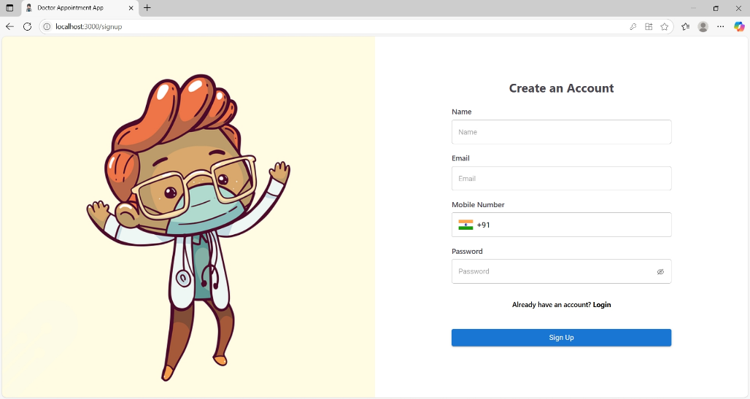
Register Page

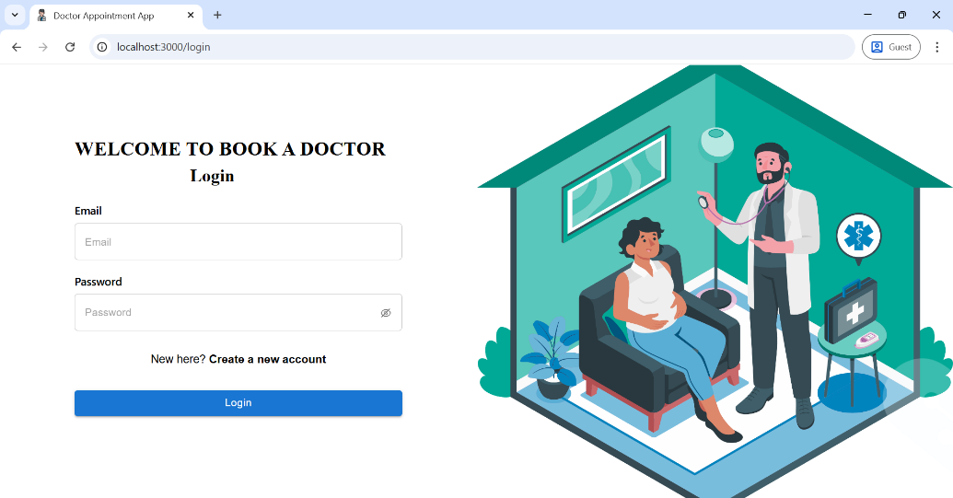
Login Page

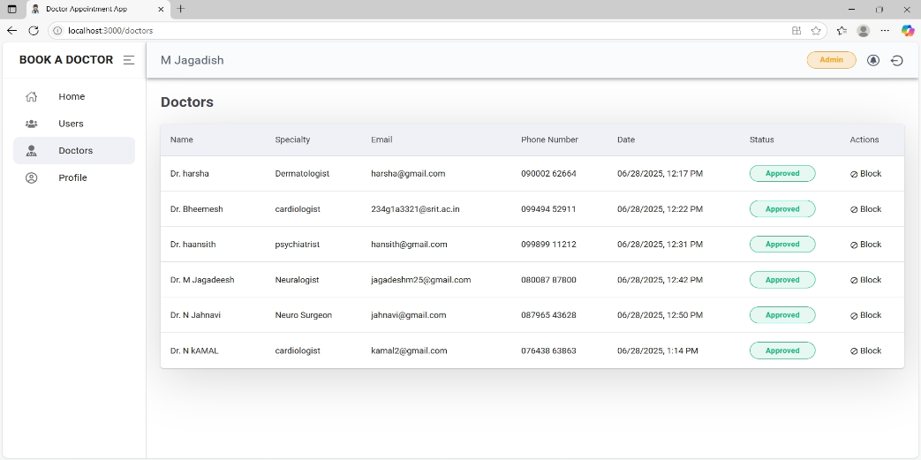
Admin Dashboard
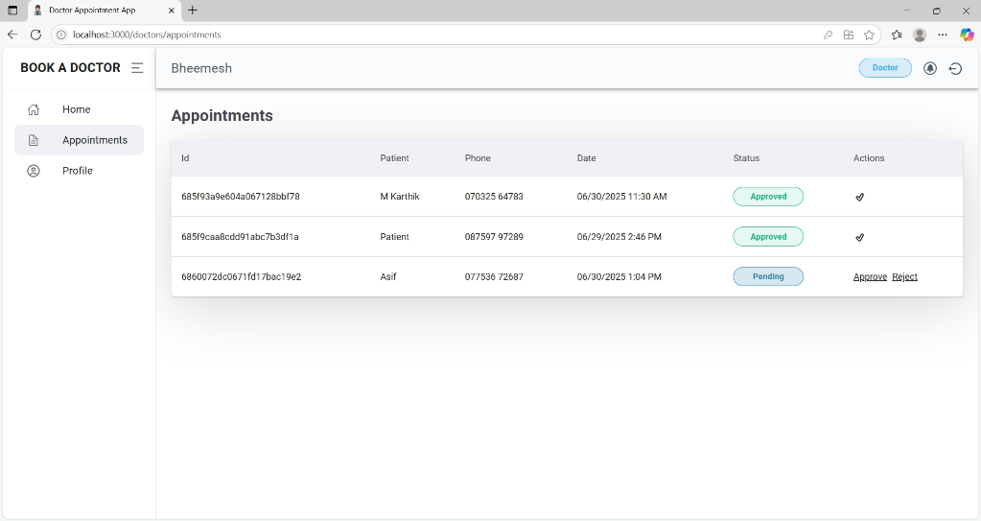
Doctor Dashboard

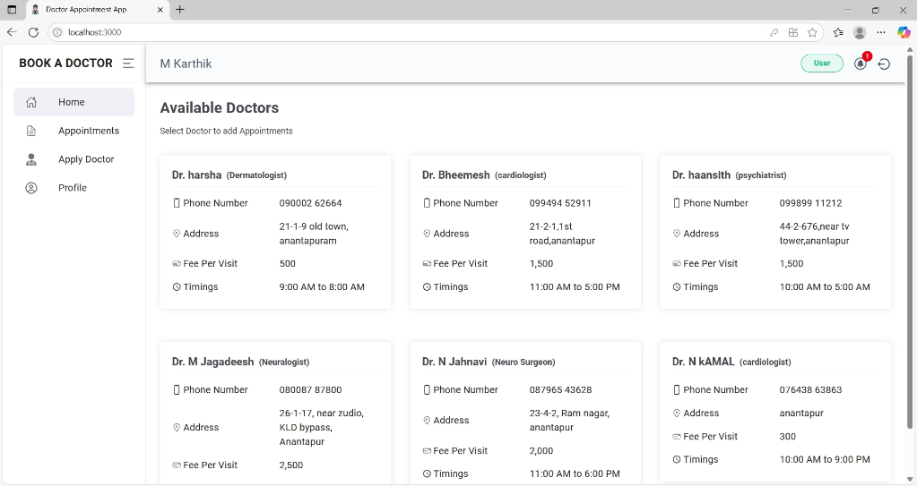
User Dashboard

The implementation of the DocSpot Booking web application was successfully completed as per the planned architecture and sprint roadmap. The application delivers a seamless and efficient way for patients to book doctor appointments online, and also provides features for doctors to manage appointments and for admins to oversee platform operations.
The major outcomes of the project are as follows:
- Functional Completion:
All major modules such as user registration, login, doctor application, appointment booking, admin approval, and real-time appointment tracking were developed and tested successfully.
- UI/UX:
A responsive and user-friendly interface was built using ReactJS, Material UI, and Bootstrap, ensuring accessibility across devices.

- Backend Integration:
A robust backend using Node.js and Express.js was implemented, with MongoDB for efficient and scalable data storage.
- Role-based Access:
Different user roles (User, Doctor, Admin) were clearly defined and implemented with secure routing and access control.
- Testing and Validation:
Comprehensive functional and performance testing was conducted. All test cases passed successfully, indicating the application meets both business and technical requirements.
- Deployment Ready:
The project runs successfully on the local server (http://localhost:3000) with backend APIs hosted on port 5000. The project is ready for deployment on cloud platforms like Render, Vercel, or AWS.

8. ADVANTAGES & DISADVANTAGES

Advantages
S.No | Advantage | Description
1. | 24/7 Accessibility | Patients can book appointments anytime, reducing dependency on reception hours.
2. | User-Friendly Interface | The system provides a smooth and intuitive experience for patients, doctors, and admins.
3. | Efficient Appointment Management | Doctors can confirm, reschedule, or cancel appointments directly through the system.
4. | Real-Time Availability | Users can view and book time slots based on the doctor’s live availability.
5. | Reduces Administrative Overhead | Automates appointment scheduling, reducing the workload of healthcare front-desk staff.
6. | Scalable Architecture | Built using scalable technologies (React, Node.js, MongoDB) suitable for future expansion.
7. | Document Upload Facility | Patients can upload medical records for doctor review before the consultation.
8. | Improved Patient Experience | No need to wait on calls; faster and more transparent booking process.

Disadvantages
S.No | Disadvantage | Description
1. | Requires Internet Access | Users without internet access cannot benefit from the system.
2. | Technical Dependency | Any downtime in server or bugs in code can temporarily block the service.
3. | Security Concerns | Handling personal health data requires strict security and privacy compliance.
4. | Initial Learning Curve | Non-tech-savvy users may need assistance using the app initially.
5. | Limited Personal Interaction | Replaces traditional receptionist assistance, which some users may prefer.
6. | Time Slot Conflicts | If not properly validated, booking overlaps or invalid times may occur.

9. CONCLUSION

The DocSpot Booking – Seamless Appointment Booking System effectively addresses the growing need for a modern, efficient, and user-friendly healthcare appointment management solution. By integrating a full-stack architecture using React.js, Node.js, and MongoDB, this platform streamlines the process of booking, managing, and confirming doctor appointments for both patients and healthcare providers.

Through real-time availability checking, document uploads, appointment history tracking, and administrative control, the system ensures an enhanced user experience and operational efficiency. The roles of different users—patients, doctors, and admins—are clearly defined, and the system supports scalability and flexibility for future improvements.

This project not only automates a traditionally manual and error-prone process but also contributes to improved patient satisfaction, better doctor-patient communication, and reduced administrative burden on clinics. Overall, the solution successfully fulfills its intended purpose and demonstrates the practical application of modern web development technologies in solving real-world problems in the healthcare sector.

10. FUTURE SCOPE

The DocSpot Booking – Seamless Appointment Booking System lays a strong foundation for transforming how healthcare appointments are scheduled and managed. While the current implementation meets essential requirements, there is significant potential for future enhancements and scalability. The following developments can be considered in future versions:
- Telemedicine Integration
Enable video consultations directly through the platform, allowing patients and doctors to connect virtually without physical presence.
- Online Payment Gateway
Integrate secure online payment options for appointment booking, including support for UPI, credit/debit cards, and digital wallets.
- Automated Reminders & Notifications
Implement SMS and WhatsApp notifications for appointment confirmations, reminders, and follow-ups to reduce no-shows.
- Advanced Search & Filters
Enhance doctor search with filters like language spoken, hospital affiliation, consultation fees, and patient ratings.
- E-prescription and Medical Record Access
Allow doctors to issue digital prescriptions and enable patients to view and download their consultation history and reports.
- AI-based Recommendations
Use AI to suggest doctors based on patient symptoms, history, or previous visits.
- Mobile App Development
Develop Android and iOS versions of the application for broader accessibility and convenience.
- Multilingual Support
Add multiple language options to cater to users from different regions and improve inclusivity.
- Feedback and Rating System
Include a system for patients to provide feedback and rate doctors based on their experience.
- Doctor Availability Sync
Integrate with doctors’ calendars (e.g., Google Calendar) to auto-update availability and avoid double bookings.

11. APPENDIX
Github Link: https://github.com/Jagadish-25/Doc-spot-Booking-.git

